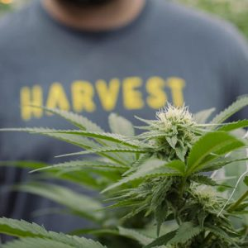
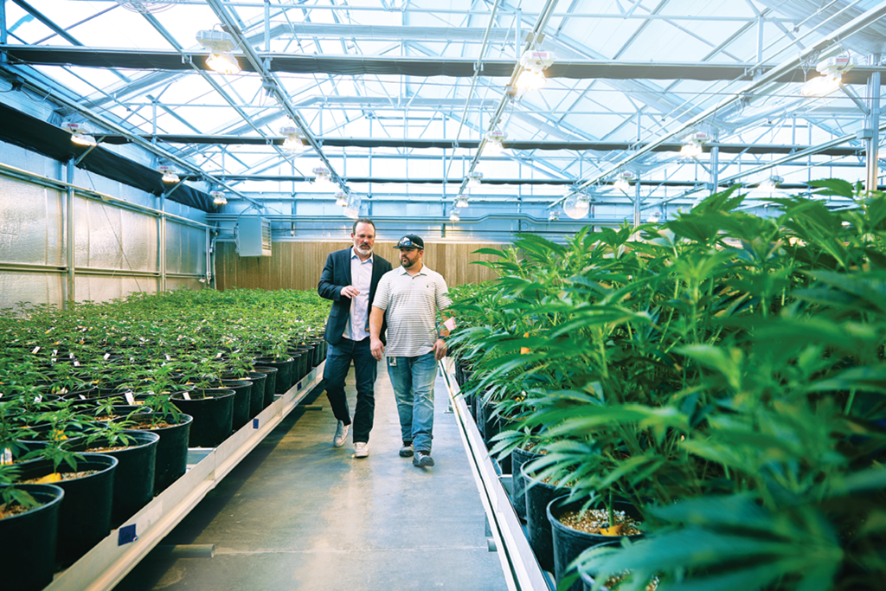
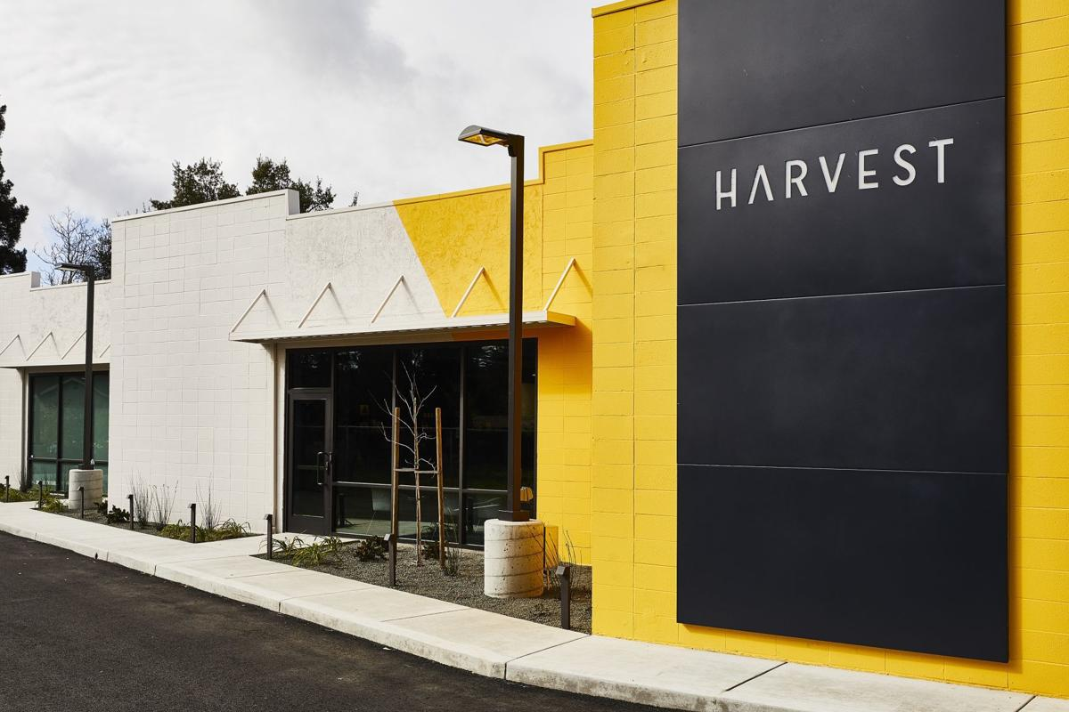
THOUGHT-LEADERSHIP PROPOSAL FOR
HARVEST HEALTH AND RECREATION
AUGUST 8, 2019
Table of Contents
Overview 2
Competitor Key Findings 3
Strength, Weaknesses, Opportunities and Threats Analysis 4
Audience Findings 5
Campaign Strategy 8
Goal, Objective and Strategy 9
Tactics 10
Channel Distribution 13
Desired Outcomes 13
Timeline 14
Budget 15

Overview: The “Platforms”
Low Barriers for Consumption of Product and Resources
1/3 of non-consumers who have never used cannabis before said they would consider trying it, and many Americans in favor of the legalization of cannabis acknowledge the need for knowledge for both consumers and non-consumers.

Lack of Education
The cannabis industry is designed for those who are frequent consumers of cannabis. Those who are frequent users- consumers who enjoy cannabis more than once a week (74% of US cannabis consumers)- know how to properly use cannabis products. Frequent users are aware of available resources whereas those who are not frequent consumers or consumers at all are not.

Legislative Barrier
The cannabis industry is highly regulated with a fragmented market due to legalization concerns. While support for legalization is growing in congress, certain opponents and groups still hold firm stances against cannabis.

Competitor Key Findings
MedMen: With trying to become the Apple Store of Weed, MedMen has exceptional executive visibility with CEO and co-founder Adam Bierman ensuring people know about the growth of MedMen. Although the conversation of growth is constantly discussed, there are low CSR initiatives and consumer activation for the company. For CSR, MedMen vaguely educates consumers on what cannabis is on one section of their website. Regarding their consumer activation, MedMen has made it clear that they are inclusive and supportive of different groups of people by partnering with Equality California for Pride Month and holding free lounges at the LA and San Diego Pride Parade.
Acreage: As a relatively new cannabis company, Acreage has made an impact pushing the legalization of cannabis in 2019. With the help of former Speaker of the House John Boehner, CEO Kevin Murphy has been very visible in various platforms that include Bloomberg’s Players Technology Summit, Fox Business, and SXSW. Even though there is much executive visibility, the level of CSR initiatives and consumer activation is close to zero.
Curaleaf: Making sure that consumers “Live Life Well”, CEO Joseph Lusardi has made himself visible enough to inform people about the representation and growth of Curaleaf through presentations and exclusive Q & A’s. Alongside Lusardi is executive chairman Boris Jordan, who informs the public about Curaleaf’s market sales and purchases. When CSR and consumer activation is concerned, Curaleaf has launched a nationwide initiative with the VCP to help bring additional visibility to this important issue and help the millions of veterans dealing with chronic pain and other conditions have better access to quality medical cannabis. On their site they also educate consumers on the botany and chemistry of cannabis. While educating consumers Curaleaf is now able to educate themselves more after launching a hemp research project back in May. And while trying to continue appealing audiences Curaleaf had added cannabis recipes to their blog.

Strengths, Weaknesses, Opportunities and Threats Analysis

Audience Findings
Audience Findings: Consumer
Mary-Jane Millennial (23- 38)
Brand Perception: Positive yet unaware.
Cannabis Perception: Recreational use is more prevalent in this generation than others. Medical use is extremely valued as well as an initiative to increase healthy lifestyle habits (this has the greatest market potential). Millennials are very opinion based which results in a varying perception. We need to influence this generation to become fact based in order to gain authority and trust in the space.
Challenges: Millennials are focused on convenience in accessibility and affordability rather than what brand they are consuming.
Opportunity: Millennials are the largest consumer group and value transparency. They are eager to learn about different opportunities regarding the industry and respect authority in the space. They are also looking to increase personal wellness (decreasing alcohol consumption) – price of cannabis products vs alcohol.
Budding Baby Boomer (55 – 73)
Brand Perception: Positive yet unaware.
Cannabis Perception: CBD is the largest appeal to this generation. CBD consumers nearly doubled in 2018 (2.6% to 4.8%) and baby boomers are the most common users of all age groups. Females are the most likely CBD users (Eaze survey).
Challenges: Baby boomers are un-educated about cannabis and the industry. They grew up in a time where cannabis had a certain stigma- one of negativity, laziness, risk, etc.
Opportunity: Baby boomers make up a significant portion of the consumer audience and are the largest growing segment, with a 25% increase over the past year (2018). They also are the biggest spenders (spend the most each month on average). They are curious about cannabis and its benefits especially regarding pain/ symptom management.

Audience Findings: Investors
- Greg Taylor: Chief Investment Officer at Purpose Investments. He has been buying US-focused cannabis stocks – specifically mentions Harvest Health & Recreation & Curaleaf Holdings.
- Tom Angell: Editor of Marijuana Moment who covers the policy and politics of marijuana. He has written for top publications such as Forbes and Huff Post in the past.
- Todd Harrison: Founder and CEO of Minyanville internet media company. Harrison has spoken in favor of cannabis and Harvest on numerous occasions on twitter and interviews with a business perspective.

Perceptions:
It is important to understand the varying discussions between investors in business and investor-focused coverage. There are discussions about both Harvest Health and Recreation and the cannabis industry more generally. In both top-tier and trade outlets there are discussions on Harvest which identify the company as a growing vertically-integrated MSO in the cannabis industry. Most of the coverage which focuses solely on Harvest are cannabis trade outlets. This coverage is mostly neutral-factual in tone but suggests continued success by Harvest in the future. This can be seen in Benzinga’s coverage that discusses Harvest’s term loan, which was secured with the intentions of using it for strategic acquisitions, general corporate purposes and working capital.
The conversations in the media regarding the cannabis industry are both neutral-factual and negative in tone. There is limited variation in the discussions surrounding the cannabis industry. Much of the business and investor trade outlets report on the concerns with investing in the cannabis industry including the fact that it is a fast-paced industry that many people, including investors, don’t feel knowledgeable on to make a significant investment in any aspect of the industry. In a Motley Fool article, the editor identifies what investors must know before investing in the cannabis industry, including the basics of cannabis and the cannabis industry. There is significant coverage on what investors should be wary of and seek more information about, but the information isn’t necessarily accessible, creating an opportunity for Harvest to take the lead in educating investors regarding these gray areas.
Challenges:
Currently, Harvest Health and Recreation faces challenges when looking to reach investors. The first evident challenge when looking at media coverage is that coverage on Harvest also includes discussions on other MSOs in the United States. This draws comparisons between Harvest and other MSOs. In coverage from Seeking Alpha, Harvest is named as a competitor to other large MSOs, such as Curaleaf.
An additional challenge Harvest faces in reaching investors is that although there is research to defend the benefits of marijuana and the reasons for use, the general public is not fully informed, making it difficult for investors to be convinced as to whether cannabis is in fact a trend or simply a fad. By reaching out to both investor and consumer audiences, Harvest has the ability to change perceptions on the cannabis industry, generating significant investment.
Opportunities:
While conversations about the cannabis industry and Harvest are happening in trade publications such as Benzinga, Motley Fool and Seeking Alpha, there is very little coverage in top-tier business outlets. Forbes is the only business-focused outlet which generated robust coverage on cannabis and Harvest, with 558 mentions in the past six months. This gap in discussions on the cannabis industry and Harvest create an opportunity for increased coverage in both top-tier and trade outlets.
The coverage that does exist highlights the spaces where increased coverage would be possible and beneficial. Most specifically, a significant amount of coverage highlights the need for increased amounts of information on both the cannabis industry and marijuana. With Harvest’s Medical Marijuana Research Institute, it is possible to increase the accessibility of information on marijuana will provide investors with the resources necessary to make informed decisions on investing in the cannabis industry.
A Motley Fool article identifies the money and worthwhile investment being in derivatives and CBD. This includes vapes, edibles and concentrates – all spaces that Harvest is already in. This assists in identifying the spaces where Harvest can insert themselves into, through executive visibility and increased awareness on where Harvest already stands in the cannabis industry, and where the company intends to expand.

Audience Findings: Policy Makers
Proponents, which are legislators from states that have seen wild success with marijuana legalization, will be used as advocates for marijuana reform lobbying efforts through a relationship building campaign. Examples include:
- Gov. Jared Polis (D-CO)
- Sen. Elizabeth Warren (D-MA)
- Gov. Ned Lamont (D-CT)
Perception:
Up until recent years, the consensus surrounding marijuana legalization, for both medical and recreational use, was mostly negative. Now, the sentiment towards marijuana has changed to a more positive note, with legislators leaning towards legalization, most notably being all 12 official Democratic candidates, as well as the potential Republican hopeful and former Massachusetts governor William F. Weld (Boston Globe).
Nearly 69% of Democrats say marijuana use should be legal, as do 75% of independents who lean left. Republicans are more divided, with 45% in favor of legalizing marijuana and 51% still opposed. However, the share of Republicans saying marijuana should be legal has increased from 39% back in 2015 (Pew Research).
Unfortunately, Harvest Health and Recreation has incredibly low brand awareness among policy makers, however, so do all its competitors.
Challenges:
Opponents can be difficult to persuade due to the stigma surrounding cannabis and marijuana and contradictory statistics from multiple partisan and bipartisan sources. In addition, some older policy makers hold residual, draconian views on marijuana policy from the War on Drugs, and shows the direct link between seniority in congress and their opinions on the legalization of cannabis for medical and recreational use (Forbes).
Opportunities:
On the contrary, many politicians, especially the younger generation, are realizing their anti-cannabis stance does not align with the views of their constituents, and ultimately has the ability to prevent them from achieving higher positions of power (Forbes). Because of this, many politicians who had opposed legalization in the past have been open to changing their stance on decriminalization (and oftentimes legalization) (Politico).
Secondary Public: Regulator’s Profile
As a secondary public, the policy makers mentioned above will be used as a vehicle of change and communication for the regulatory agencies on the national level as a long-term campaign. Because the legality of marijuana is dependent on the state, it is important to use the strategy and tactics for policy makers to build the relationship between Harvest and various congressmen and women as continuous proponents for legalization, which will persuade the regulatory agencies over time. While these tactics take time, they are essential to the entire cannabis industry.
By using long-term relationship building tactics, policy makers can become stronger proponents for legalization and control its status through future political campaigns. The regulatory agencies (FDA and USDA) are a secondary public and will be reached through political advocates over time.

Campaign Strategy
A paid and earned media-based approach to bring awareness to topics in cannabis through a thought leadership campaign, highlighting the benefits of the budding industry.
What are we going to do?
We will be targeting the whitespace in the industry – education. Through investigation and understanding of the media landscapes and discussions surrounding the cannabis industry, we will create transparent conversations about the cannabis industry to create a space for discussion, making it both a more comfortable topic as well as increasing informed discussion on the topic.
Increased conversations with Harvest’s key audiences can be created through executive visibility, positioning reputable individuals from Harvest that can speak to the statistics surrounding the cannabis industry. This will not only increase awareness and knowledge on the cannabis industry, but also bring awareness to the knowledge that is held in the C-suite at Harvest Health and Recreation.
Why we are doing this?
Through research and competitor analyses, it was discovered that Harvest possesses an interesting advantage over its competitors: an incredible and robust CSR program, especially its research institute and focus on broadening acceptance and understanding of cannabis and the industry. While competitors lack this resource and mission, Harvest does not exploit its education and CSR initiatives as its differentiating factor in the market.
How will it work?
This education-centered approach will focus on the consumers’ wishes for more accessible and consistent information by providing a reliable source, Harvest Health and Recreation and its proprietary research division, the Medical Marijuana Research Institute. In addition, partnering with reputable establishments reinforces Harvest’s role as the only cannabis company striving to educate not just consumers, but non-users.

Goal, Objective and Strategy
Goal:
To become an authoritative leader in the cannabis industry through:

Strategy:
To position Harvest Health and Recreation as the premiere source for cannabis information

To educate Harvest Health and Recreation key audiences through executive storytelling utilizing a channel agnostic approach through:
Paid Media  Through native advertising, social media and promoted posts, Harvest can target key geographic locations. Paid media amplification can drive awareness and understanding of the cannabis industry. | Earned Media  Through outreach to trade and consumer outlets, earned coverage can be acquired through media days, editorials, investor conferences, think tanks, media roundtable, and curated dinners. | Owned Media  Leverage Harvest’s owned media assets, which can highlight earned media placements and can be additionally amplified through paid digital and social media channels.

Tactics
Consumer
Using a 3-phase strategy utilizing a full funnel approach, BCW will drive brand awareness and increase brand reputation of the company, differentiating it from industry competitors.
- Native Amplification on premium publications
  - Documentary web series that lives on Harvest’s website
    - Extension of the thought leadership campaign: 5 episodes for 60 seconds each
    - Executives of Harvest such as Steve White, Jason Vedadi, and Nicole Smith will conduct a scripted dialogue informing viewers of Harvest’s CSR and sustainable initiatives
      - Employees of Harvest will partake in the videos taking viewers through their agricultural fields and processing facilities. Viewers will be taken through each step of the creation of Harvest’s products from growth to dispensary.
    - The video will be created by a micro influencer who specializes in creative video curation. He/she will then push this video on his own social channels in order to hit an audience larger than Harvest’s scope but one that aligns with its target demographics.
    - Harvest’s website will be pixeled: site visitors will be served a cookie asking them to enter their email if desired for more information and a survey. This will then allow Harvest to re-target site visitors with the same content through social amplification.
  - Harvest’s Earned Media
    - Amplification of Harvest’s white paper to publications where targeted audience lives (refer to section for further detail on white paper)
- Social Amplification
  - Micro influencers attract a more authentic and engaged audience. Finding a micro influencer with an audience that aligns with Harvest’s will engage broader audiences that take special interest in the content.
    - BCW will create partnerships with additional micro influencers to engage all three key audiences (consumers, investors, elected government officials and regulators)
      - Two B2B micro influencers
        - Tom Angell: Editor of Marijuana Moment. He is a 15-year veteran in the cannabis law reform movement, he covers the policy and politics of marijuana. Founder and chairman of Marijuana Majority (non-profit). Angell has written for top publications such as Forbes and Huff Post.
        - Todd Harrison: Founder and CEO of Minyanville internet media company. Harrison has spoken in favor of cannabis and Harvest on numerous occasions on twitter and interviews with a business perspective.
    - Editorial blog posts amplified on LinkedIn for all key audiences
      - Editorial posts will be a series of 3 pieces written by Executives such as Steve White, Jason Vedadi, and Nicole Smith about various topics in the cannabis industry such as legalization, industry trends and areas for growth, and general FAQ
- Using the email capture from site pixeling, a survey will be sent out to the CRM targeted audience list
  - This provides Harvest with a measurement of change in brand advocation and or ongoing perception change.
  - Allows options for re-targeting and or building a look-a-like audience for future campaigns.

Investors
Media production/embargoed outreach: Offer an embargoed exclusive of Steve White’s media production day with business and investor trade outlets and a consumer publication.
- Pitching angle: Present either CEO Steve White or COO John Cochran to speak about the trends in the industry and support, through statistics, where these execs see the industry going – this will position Harvest in a way that they are leading the industry through education

Media day: Separate from a media roundtable discussion

Sample Media Day Schedule
Time (ET) | Ideal Targets
7:30am – 9:00 am | Morning Broadcast Interview (Cheddar, News Talk Arizona)
9:30am – 11:45am | On-Camera Interviews (CNN, ABC News, CNBC, MSNBC, CBS)
12:30pm – 1:00 pm | In-Studio Broadcast Interviews (SiriusXM, Talk Stoop, Daily Blast Live)
1:30pm – 2:00 pm | Lunch Break
2:15pm – 3:30pm | Media Round Table “Smoke Circle/Session” (Forbes, Barron’s, New York Times, High Times, USA Today, Fortune, Business Insider, Investor’s Business Daily, Seeking Alpha, Benzinga)

- Media Roundtable “Smoke Circle/Session”: in addition to a traditional media day, host a round table discussion, creating an informative robust discussion on marijuana and the cannabis industry as well as the opportunities for reporters to learn more about the campaign from Harvest executives
  - In each state that Harvest operates and where marijuana is legal, the company will host a “smoke circle” media roundtable with select journalists and outlets
    - The high-quality but low dosage of marijuana will be provided by Harvest to serve as a product sample
    - Exclusive content for journalists and publications
  - Why it works: A media roundtable will allow reporters to determine their own story angles from the information presented at the event rather than just focusing on a celebrity interview. In addition, the event will create an informative and robust discussion because editors can bounce ideas and questions off each other
Position executive at an investor/business conference
- South by Southwest Business Conference – March 13-21, 2019
  - CEO Steve White or COO John Cochran will be able to speak about the cannabis industry and trends as it relates to investors
  - Who will be in attendance: A variety of professional individuals looking at both high- and low-risk investments
  - Why it works: The event generates a discussion with a wide range of professionals who are able to discuss questions and ideas revolving around investment in the cannabis industry

Policy Makers/Regulators
Think Tank:
- Includes a panel discussion with Harvest executives, government officials for the legalization of marijuana, and various doctors and researchers whose work focus on cannabis
- Partnership with institution such as Brookings
  - Who will be in attendance: Outlets such as CNN, Forbes, The New York Times, VICE and High Times
  - Why it works: Harvest executives can build their reputation as a thought leader by engaging in thought-provoking conversation with important policy makers and leading doctors, with coverage coming from a variety of trusted outlets and trade publications

Salon dinners with legislators:
- Private dinners with policy makers in private, off-the-record environment
- Relationship-building tactic to create support for Harvest brand as well as cannabis industry
  - Who will be in attendance: Invited policy makers who are known proponents of marijuana, and Harvest executives
  - Why it works: Since cannabis proponents are already active, they will be more willing to become advocates for the success of their states on behalf of Harvest and the entire cannabis industry. This creates media opportunities for both Harvest and involved policy makers in the long term

White paper:
- Partnership with the University of Florida
  - Why it works: Harvest opened its Gainesville, Florida, location August 2, 2019, minutes away from the University of Florida, a leading school for agricultural sciences. In addition, the Florida Board of Governors had selected UF to lead a statewide consortium studying health outcomes related to medical marijuana and the Industrial Hemp Pilot Project through UF’s Institute of Food and Agricultural Sciences. This organization, paired with Harvest’s personal research institute, makes for a reputable white paper.

Channel Distribution
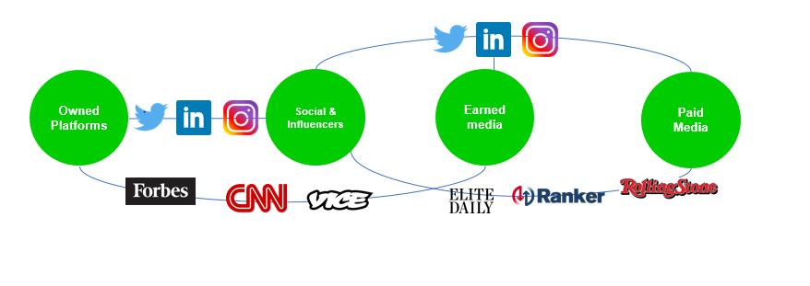
Desired Outcomes
With this campaign and the designed tactics, the long-term desired outcome is to broaden acceptance and understanding of cannabis and the cannabis industry in Harvest’s key audiences. With each set of tactics targeting a specific key audience group, different short-term outcomes will contribute to the overall long-term goal of sustainable educational initiatives with the hopes of increased acceptance and subsequent support for legalization. By providing transparent and reputable information supported through research, Harvest will be paving the way to destigmatization as leaders in the industry.

Timeline
First 30 Days | 30 to 90 Days | 90 Days & Beyond
Lay the Foundation  Prepare initial media audits and assessment of Harvest’s resources.  - Conducting a news and social media audit  - Pre-focus group study  - Conducting an audit of current resources  - Develop social media content  - Confirm spokesperson  - Target identified policy makers for government affairs strategy  - Application to South by Southwest for conference  - Daily media monitoring of client and related topics (ongoing)  - Initial media outreach and assessment  - Research and identify potential partnerships that would best serve the interest of the client  - Curate and create supporting assets, such as fact sheets and backgrounders, images and other content  - Conduct internal stakeholder briefings, as needed | Create the Structure  Following initial audits and confirmation of spokesperson, develop a plan to initiate tactics.  - Confirm partnerships  - Schedule media day, production days, social amplification launch of documentary series, think tank, curated dinner with legislatures  - Continue media outreach and secure interviews and partnerships  - Deploy tactics for government affairs strategy including sending informational materials,  - Focus group study  - Prep spokesperson to speak to media | Operate the News Bureau  BCW will collaborate with Harvest communicators to conduct targeted earned media outreach and amplify coverage.  - Post-focus group study  - Amplify earned media placements  - Evaluating KPIs and campaign success  - Continue to deploy campaign or revise as necessary

Budget
Option 1
Services/Deliverables | Fees
Billable Hours
On-Call Communications Counsel
Team Designation
Day-to-Day Account Management
Government Affairs Engagement
TOTAL: | $243,000
Paid/Digital Media
Native Amplification | $100,000
Social Amplification | $110,000
TOTAL: | $210,000
Creative/Influencer
Influencers (@$25,000 each) | $100,000
TOTAL: | $100,000
Partnerships
Educational institution | $30,000
Think Tank | $17,000
TOTAL: | $47,000
TOTAL: | $600,000

Option 2
Services/Deliverables | Fees
Billable Hours
On-Call Communications Counsel
Team Designation
Day-to-Day Account Management
Government Affairs Engagement
TOTAL: | $363,000
Paid/Digital Media
Native Amplification | $50,000
Social Amplification | $50,000
TOTAL: | $100,000
Creative
In-House Content Creation | $60,000
TOTAL: | $60,000
Partnerships - optional
Educational institution | $30,000
Think Tank | $17,000-$47,000
TOTAL: | $47,000-$77,000
TOTAL: | $570,000-$600,000

Paid Media Breakdown*
Native
- Documentary Series: 40K, CPM $2-$5 8,000,000 - 20,000,000 Impressions
- Earned Media: 30K, CPM $2-$5 6,000,000 – 15,000,000 Impressions
- LinkedIn: 30K, CPM $2-$5 6,000,000 – 15,000,000 Impressions
Social
  - Documentary Series: 30K, CPC $0.25- $0.75 40,000 - 120,000 Clicks
  - Micro Influencers: 100K, CPC $0.25 - $0.75 1,440,000 – 4,320,000 Clicks

