Diversity Action Alliance
Social Media Standard Operating Procedure

Our Platforms
- Twitter
- Facebook
- LinkedIn
- Instagram

Our Voice
- We are storytellers and industry leaders.
- We are witty and professional.
- We are constantly engaging in the media landscape and staying current with trends.

Our Content
Our content is professional but engaging, showing our brand voice and organization’s mission through high-quality photos and other forms of content whether that be via Twitter, Facebook, LinkedIn or Instagram.

Our Primary Publics
- Industry Professionals
- Academics
- Students

Posting Guidelines
Twitter

Platform Goal
To showcase our presence by sharing relevant diversity and inclusion news, industry trends, organization updates and directly interacting with our publics.

Post Cadence
In addition to the scheduled post, we will tweet unscheduled tweets 3-4x per day. Content does not need to be original for the additional posts, but the one with the most engagements will be tracked in the calendar to determine best practices.

Best Practices
- We schedule one tweet per day and tweet (or retweet) at least 3 other times -- these are considered unscheduled tweets.
- We track the scheduled tweet and the unscheduled tweet with the most engagement in the calendar.
- We do not voice political opinions.
- We maintain a neutral tone and do not engage in argumentative tweeting.
- We do not tweet before 9 a.m. and after 7 p.m. unless for an event or special circumstance.
- We always live-tweet at relevant events and meetings.
  - Post 7-9 live tweets and intro and exit tweets.
  - Make sure to tag speakers and organizations and use event hashtags.
- We always respond to engagement.
  - Decide whether or not a like, retweet or reply is appropriate.

Scheduled Content Categories
- GIFS
- DOW: Hump Day, Sunday Scaries, Etc.
  - These will be kept at a minimum
- Interactive Polls
- Scholarships
- News/Updates
- Twitter Conversations
- Branded Photos/Items
- Infographic promoting organizational initiatives, events, etc.
- Blog promotion

Unscheduled Content Examples

- Retweeting or engaging in current news/trends (below are examples of accounts to stay updated with)
  - @PRSA
  - @instituteforPR
  - @PRNews
  - @PRDaily
  - @Adweek
  - Etc.
- Interact with other organizations through likes, retweets, quote tweets, etc.
- Live tweet events
- Interactive polls
- Linked Facebook or Instagram posts

Facebook

Platform Goal
A more in-depth view into Diversity Action Alliance as an organization.

Post Cadence
Minimum of 3x per week.

Best Practices

- We use Facebook as a more comprehensive view of DAA
  - Who we are
  - What we do
- We only post between 9 a.m. and 7 p.m.
- We repost all of our Instagram posts to Facebook
- Our Facebook copy is longer, detailed and more comprehensive
- Do not include hashtags
- Upload videos
- Event Promotion
  - Promote on page and create separate event pages for sharing and RSVPs.
LinkedIn

Platform Goal
A more in-depth view into how Diversity Action Alliance impacts the future of the industry.

Post Cadence
Minimum of 3x per week.

Best Practices

- We only post between 9 a.m. and 7 p.m.
- LinkedIn copy is longer, detailed and more comprehensive
- Tag appropriate organizations and individuals

Content Examples
- Share blog posts
- Share relevant diversity and inclusion news and articles
- Upload videos (if relevant)
- Highlight committee members’ accomplishments
- Organization milestones
- Event Promotion
  - Promote on page and create separate event pages for sharing and RSVPs.

Instagram

Platform Goal
To promote the Diversity Action Alliance’s mission visually.

Post Cadence
Between 1 to 2 times per week.

Best Practices

- We post high-quality and relevant content on Instagram 1-2 times a week.
- We only post between 9 a.m. and 7 p.m.
- We use relevant hashtags beneath captions.
- We interact with other organizations through likes, comments and following new brands.

Content Examples
- Updates
- Holidays
  - Make sure holidays are relevant and inclusive.
  - National Coffee Day, Happy Holidays, New Years, etc.
- Branded Photos/Items
- Infographics promoting organizational initiatives, events, etc.
Content Calendar Format

This is to be filled out with our scheduled content every month for every week. This is where posts are planned and approved for each platform.

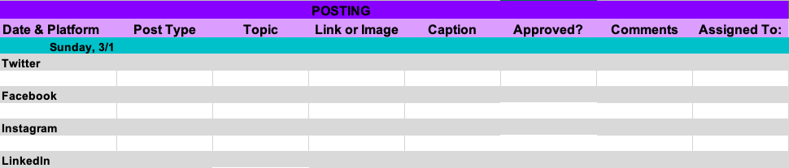

Breakdown of Each Category

- Date & Platform: This is the day the post would be uploaded on which platform.
- Post Type: Differentiate between IG feed or IG story post; an original tweet or a tweet with a GIF; a Facebook album or photo -- explain what kind of post it is.
- Link or Image: If a photo or link is included for the post, include it here for easy access.
- Caption: The caption should be the exact caption that will be uploaded. If emojis are going to be used, make sure to include them.
- Approved?: This column will be hired in green (approved), red (rejected) and yellow (needs improvement).
- Comments: This column will include comments made by whoever approves social posts.
- Assigned to: Who is responsible for posting.

Metrics

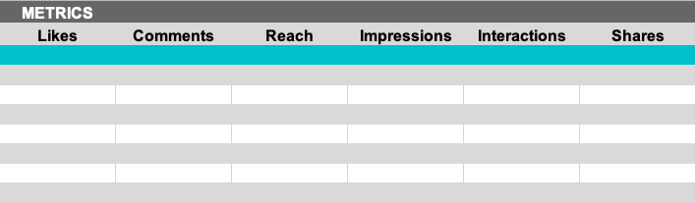

- Impressions: to be pulled from Twitter Metrics.
- Reach: to be pulled Instagram and LinkedIn Metrics.
- Likes/Comments/Replies: to be pulled from Twitter, Instagram, LinkedIn and Facebook Metrics.
  - List the amount we get for each.
- Shares/Retweets: to be pulled from Facebook, LinkedIn and Twitter Metrics.
  - List the amount we get for each.
- All metrics must be updated 7 days after posting.
- At the end of each month all of our statistics should be filled out completely to track our engagement and which posts work best.

