IPR BEST PRACTICES FOR LIVE-POSTING EVENTS

Table of Contents
OUR PLATFORMS 2
RESPONSIBILITIES 2
OUR VOICE 2
OUR CONTENT 2
GENERAL TIPS 2
TWITTER 3
Platform Goal 3
Post Cadence 3
Best Practices 3
Style Tips 3
Ideas for Engagement 4
INSTAGRAM 5
Platform Goal 5
Post Cadence 5
IG Story Dimensions 5
Best Practices 5
Style Tips 5
Ideas for Engagement 6

OUR PLATFORMS

- Instagram
- Twitter

RESPONSIBILITIES

- Stay true to IPR brand voice
- Accurately chronical event
- Interact with followers

OUR VOICE

- We are a global leader for the science beneath the art of public relations
- We are advocates for planning, research and measurement in public relations
- We embody the values of the organization and the integrity of public relations

OUR CONTENT

Our content is current and relevant research and industry-related news. We frequently post about our own content as well as share the content of our trustees and company partners. We showcase our brand through high-quality photographs, graphics and other forms of content on Twitter, Instagram, Facebook, LinkedIn and YouTube. For live posting, however, we mainly use Twitter and IG Stories, with event recaps posted to all platforms (except YouTube) following the event.

GENERAL TIPS

- Use event-specific hashtags
- Ensure names are spelled correctly
- Tag the appropriate people
- Assign one person to Twitter and one to IG Stories to maintain consistent style and voice and to prevent repeated quotes or posts
- Ensure equipment is charged and is located near an outlet or has a portable charger
- Arrive to events early to select a good seat

TWITTER

Platform Goal

To inform and engage followers during industry relevant IPR events

Post Cadence

There is no recommended cadence for live tweeting, however, it is common to tweet upwards of 10 tweets or more per hour, depending on the event.

Best Practices
- Use the branded event hashtag in every tweet
- Verify names are spelled correctly before posting and tag people, if possible
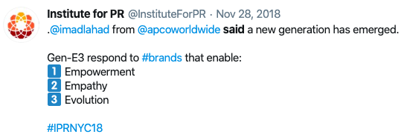
- If using Hootsuite, use two different streams on the dashboard: one for all content posted with the event’s hashtag, and another of a Twitter list of all the relevant people involved in the event, including speakers, winners, trustees and other honored guests
Figure 1: Example of a tweet that uses simple yet powerful quotes from the correctly attributed speaker, the correct event hashtag and minimal emojis.
- Schedule posts for time-specific events, such as the event commencement, a new speaker and other related announcements
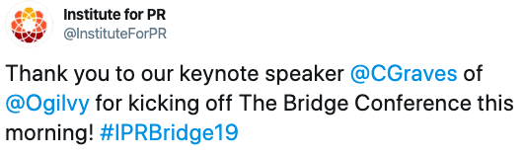
- For future tweets that are occurring at an unknown time, draft them in a Google Doc for quick access; make sure to check the character count and shorten links so the only required steps are copy, paste and tweet
- Quote only the best quotes and insights from speakers and make sure they are transcribed and tagged correctly
- Monitor Twitter regularly to see if attendees are accidently using the wrong hashtag so that they are not missed during community management
Figure 2: Example of scheduled tweet.
- Double check spelling and AP Style before posting

Style Tips
- Use only high-quality photos, videos and graphics
- Keep emoji use to a minimum

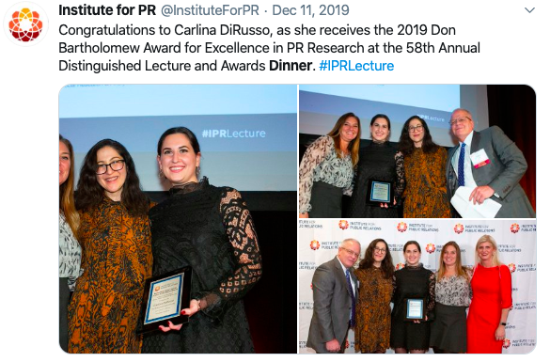
Ideas for Engagement
- Quote speakers’ and presenters’ best quotes or key takeaways
- Answer questions asked by the audience during Q&A sessions
- Post questions or polls for followers to answer
- Post photos, videos and graphics from the event
- Retweet, quote or reply to tweets or comments from speakers and presenters
Figure 3: Example of a tweet that uses high quality images from the event.
- Retweet, quote or reply to tweets or comments from other followers

INSTAGRAM

Platform Goal

To provide authentic live and behind-the-scenes (BTS) experiences to followers

Post Cadence

There is no recommended cadence for live-posting events on IG Stories, however, the most common practice is between 1-3 Stories per hour for slower events, and 3-5 for more engaging events

IG Story Dimensions
- Video or photo aspect ratio: 9:16
- Video or photo size: 1080 x 1920 pixels
- Max video length: 15 seconds
- Reminder: Recorded videos longer than 15 seconds are automatically split up and posted as consecutive 15-second long videos

Best Practices
- Make sure IG Story flows chronologically in order to accurately document the even; incorporate storytelling
- Use the correct hashtag and verify names are spelled correctly before posting
- Make posts interactive so attendees and regular viewers can engage with content
- Select short but powerful quotes when repeating a speaker’s speeches and/or comment
- Stay consistent to brand voice and style guide
- Change position and angles often to prevent boring viewers
- Keep Stories short and simple- they must capture the viewer’s interest in the first three seconds
- After the event, add all relevant stories to Highlights with appropriate IG Story Highlight cover image

Style Tips
- If you take photos or videos outside of the Instagram app, shoot content vertically to use screen room as efficiently as possible
- Use a variety of Story formats, including photos, videos, boomerangs, type and live
- Experiment with typefaces, pen tools and stickers to create engaging content while staying consistent to brand voice and style guide
- Layering and/or complementing typefaces, placing text over doodles, using the eyedropper tool to match colors to images, and using various stickers are common IPR IG Story practices, but do not overdo it
- When tagged in an IG Story, add a comment and share the post to the IPR IG Story as well
- Make sure to stay within the blue lines located on the sides and corners of the screen to ensure stickers and text are visible to all users
- Experiment with angles and sizes to create aesthetically pleasing posts

Ideas for Engagement
- Use hashtag and encourage followers to use it while posting
- Run interactive contests for viewers
- Try IG Live for longer sessions
- Host a Q&A or AMA session
- Ask questions for viewers to answer or post a poll

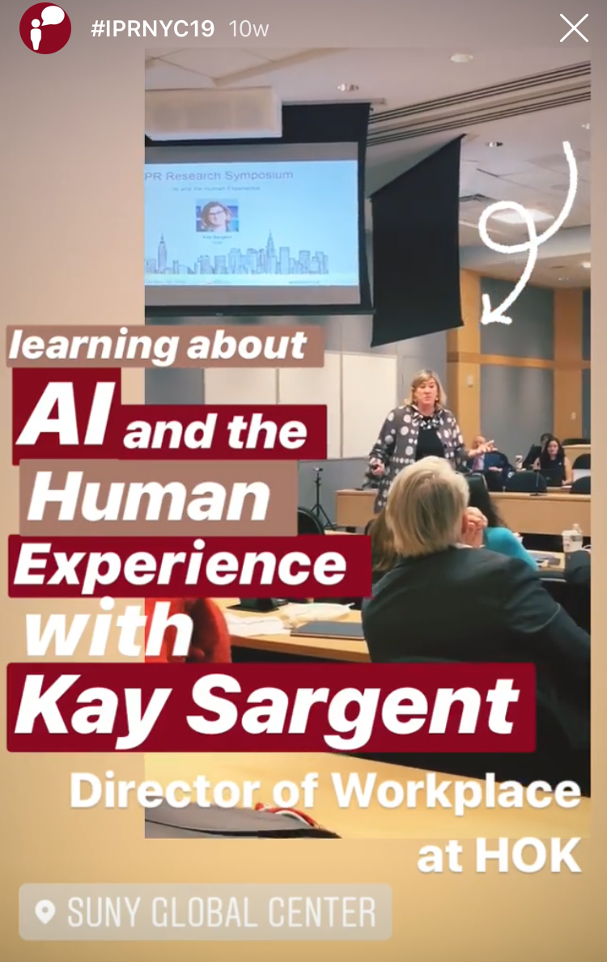
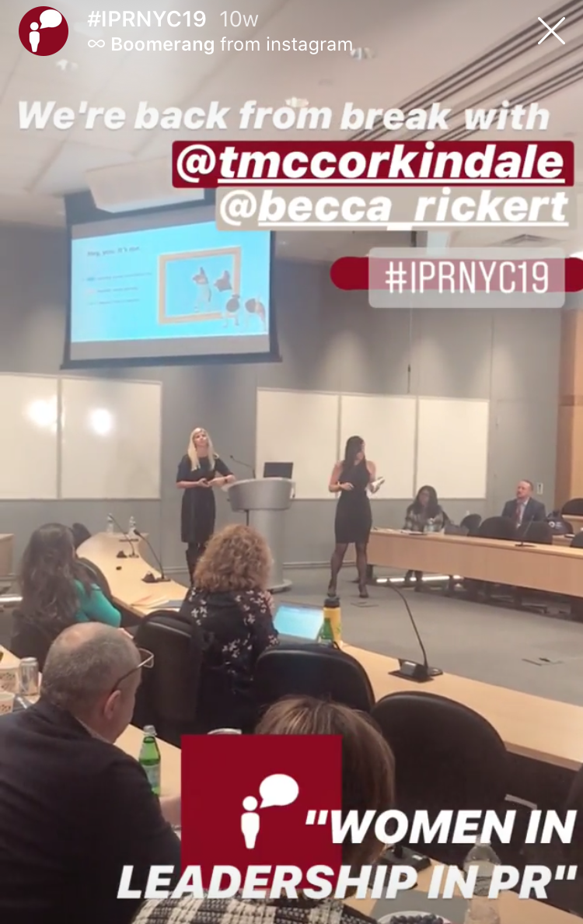

Figure 5: IG Story photograph that uses two stickers and experiments with various typefaces, font sizes and colors.
Figure 4: IG Story with using the boomerang effect, branded hashtag and pen tool.

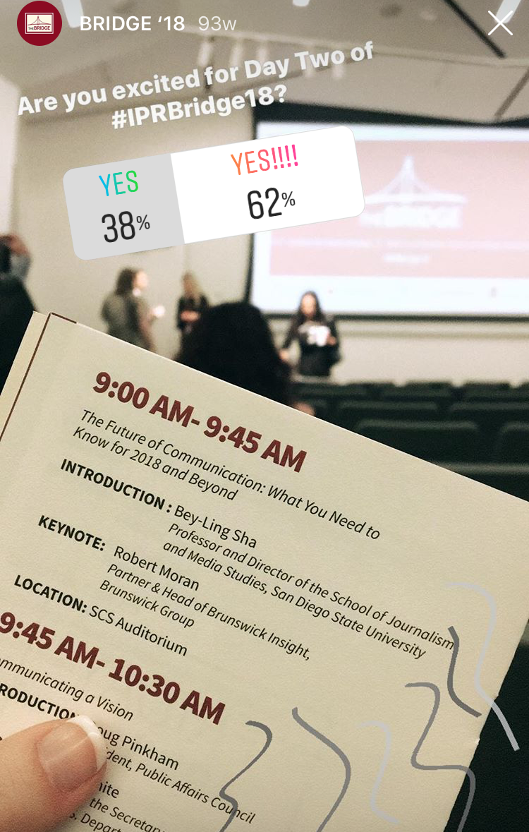
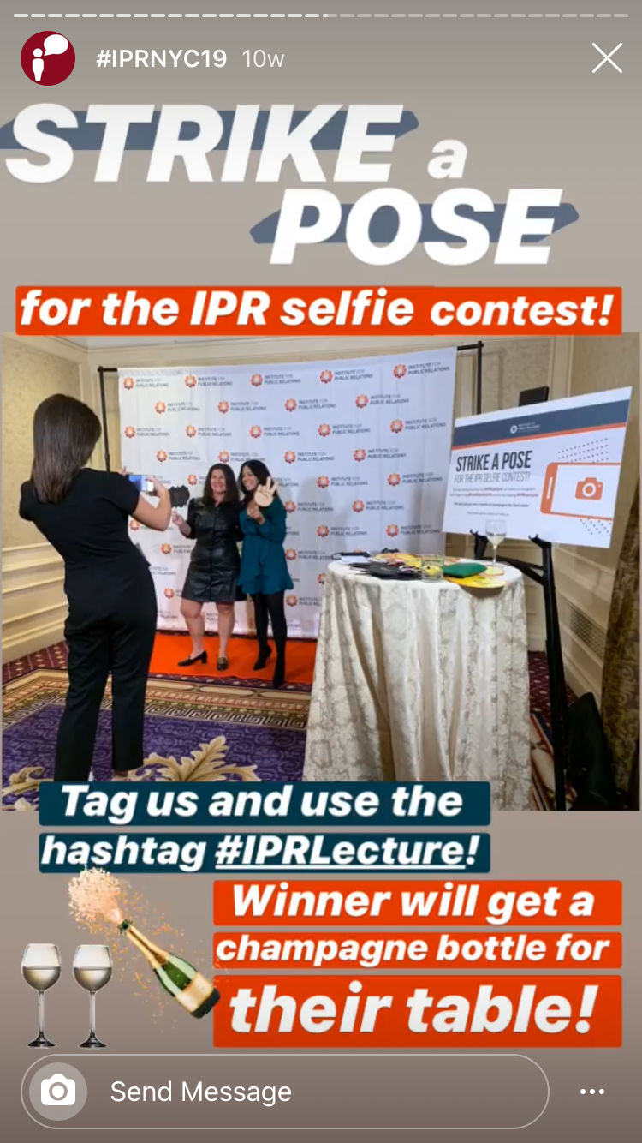
Figure 7: IG Story that plays with angles and uses the poll sticker to engage with viewers.

Figure 6: IG Story with a photo (that should be vertical) with an engaging call-to-action, fun stickers, the event hashtag, and experiments with typefaces, font size and color, and the pen tool.

